**Project Design Phase**

**Solution Architecture**

|  |  |
| --- | --- |
| Date | 15 February 2025 |
| Team ID |  |
| Project Name |  |
| Maximum Marks | 4 Marks |

**Solution Architecture:**

Solution architecture is a complex process – with many sub-processes – that bridges the gap between business problems and technology solutions. Its goals are to:

* Find the best tech solution to solve existing business problems.
* Describe the structure, characteristics, behavior, and other aspects of the software to project stakeholders.
* Define features, development phases, and solution requirements.
* Provide specifications according to which the solution is defined, managed, and delivered.

**Example - Solution Architecture Diagram:**

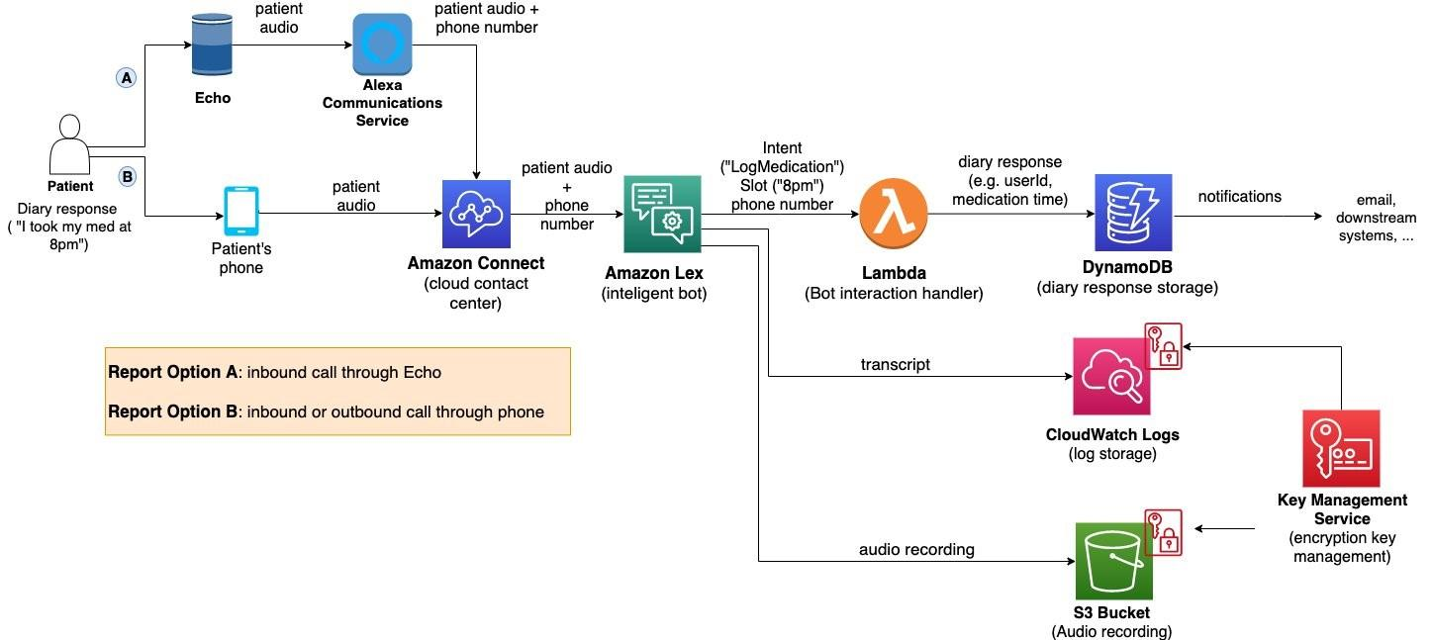

*Figure 1: Architecture and data flow of the voice patient diary sample application*

**Reference:** [**https://aws.amazon.com/blogs/industries/voice-applications-in-clinical-research-powered-by-ai-on-aws-part-1-architecture-and-design-considerations/**](https://aws.amazon.com/blogs/industries/voice-applications-in-clinical-research-powered-by-ai-on-aws-part-1-architecture-and-design-considerations/)

**SOLUTION ARCHITECTURE:**

Solution architecture is the structure and design plan of our ShopSmart application.

This digital grocery store project solves the problem of long queues, poor inventory tracking, and limited digitalization in traditional grocery shopping.

Our architecture includes:

->A React frontend for user-friendly UI/UX.

->A Node.js+Express backend to handle customer requests and business logic.

->A MongoDB database to store user details, product information, and orders.

->APIs to handle login, product browsing, cart management, and checkout.

**GOALS OF THE SOLUTION ARCHITECTURE:**

**1.SOLVE BUSINESS PROBLEMS:**

Helps small stores go digital and provide a better shopping experience.

**2.DESCRIBE STRUCTURE AND BEHAVIOUR:**

Explains how frontend,backend, and database interact with each other.

**3.DEFINE FEATURES AND PHASES:**

->**PHASE 1:** User authentication and product browsing

->**PHASE 2:** Cart and checkout.

->**PHASE 3:** Admin product management.

**4.PROVIDE SPECIFICATIONS:**

->**FRONTEND:** React

->**BACKEND:** Express( Node.js )

->**DATABASE:** MongoDB

->**HOSTING:** Render/Netlify for frontend, Cyclic for backend.

**ARCHITECTURE LAYOUT:**

[ USER ( MOBILE/WEB ) ]

|

[ REACT FRONTEND ]

|

[ Node.js+Express Backend ]

|

[ MongoDB Database ]

**ARCHITECTURE DIAGRAM:**

